Mrs. Wigginton’s Related Arts Schedule
Ms. Hofer | M-Computer  T-Library  W-Music  Th-Gym  F-Art | Ethan Banholzer  Simone Brinkman  Gabriel Champ  Jocob Deer  Kushpreet Singh
Mrs. Goedeker | M-Art  T-Computer  W-Library  Th-Music  F-Gym | Abigail Firich  Erica Franklin  Emma Gill  Josslynn Harbert
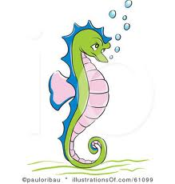  Mrs. Roy | M-Library  T-Music  W-Gym  Th-Art  F-Computer | Sarah Hoggatt  Gursharan Kaur  Namjeet Kaur  Michael Linneman
Mrs. Wyatt | M-Gym  T-Art  W-Computer  Th-Library  F-Music | Addison Martindale  Wiatt McLaughlin  Jordan Pennington  Avery Pilch
Mrs. VonDielingen | M-Music  T-Gym  W-Art  Th-Computer  F-Library | Luke Saylor  Harjot Sidhu  Nevaeh Tompkins  Skyler Nelson

